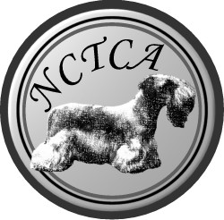 | NCTCA Registered Breeder Contract

Instructions: Please review and initial the attached Code of Ethics. Print the date and your name(s) in the spaces below, and sign where indicated. Make a copy for your records, and return the original contract and initialed code of ethics, to Lynne Yackel, Secretary, NCTCA before February 15, 2005.

Date: ________________________

Applicant Name(s): _____________________________________________________________
(Please print)

For the year of: _____2005____________________

I/We, the undersigned, wish to be a Registered Breeder(s) with the National Cesky Terrier Club of America. I/We have read and initialed the attached NCTCA Code of Ethics, and certify that I/we understand and agree to abide by the provisions therein.

I/We understand that Registered Breeder status is a privilege, which entitles me/us to be listed as Registered on the NCTCA Breeder Listing and in NCTCA printed materials, and to use the NCTCA Registered Breeder logo on my/our own webpage or written materials. I/We understand and agree that Registered Breeder status can be revoked at any time due to a violation of the Code of Ethics, and agree to, upon request by the NCTCA, immediately remove the Registered Breeder logo from all media in the event of suspension of Registered Breeder privileges.

I/We further understand that this agreement is a binding contract between myself/ourselves and the NCTCA, and this contract is subject to periodic renewal on an annual basis, or at any time there is a significant change to the Code of Ethics.

Signed: __________________________________________________
Registered Breeder Applicant

Signed: __________________________________________________
Registered Breeder Co-Applicant

Signed: __________________________________________________
Secretary of the National Cesky Terrier Club of America

